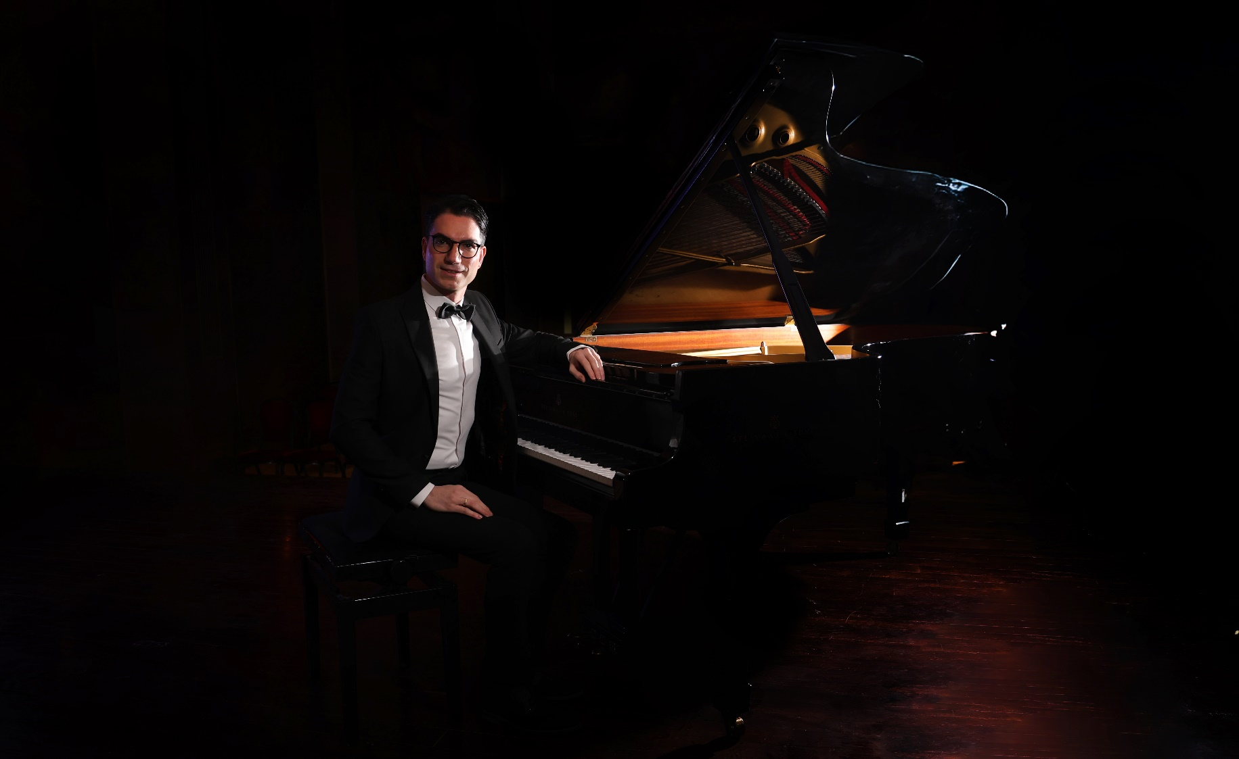

SHORT BIO
Jiries Boulata is an award-winning pianist, composer, music professor, and architect from Jerusalem (*1986), with a successful career in performance and teaching spanning over a decade. His repertoire includes classical music, Arabic music, and his own compositions. Jiries has taught at several conservatories and universities in the Middle East and Europe. He is dedicated to developing special educational methods, curricula, and music for teaching children. Jiries’ compositions blend Western classical and scale-based oriental music. He uses music as a way to convey the story of his homeland, expressing hope, love, and peace.

CONTACT
Jiries Boulata  www.jiriesboulata.com  info@jiriesboulata.com  +41 76 361 8479 | Management and Booking  management@jiriesboulata.com  +49 17634652801

LONG BIO
English
The Palestinian pianist, composer, music lecturer and former architect Jiries Boulata was born in Jerusalem in 1986 and received his first piano lessons at the age of 7. Thanks to his exceptional talent, he was accepted at the private conservatory Magnificat Institute in Jerusalem and won numerous 1st prizes at piano competitions during his youth including “Premio Università Popolare di Milano”, “Ni’was” Award for Creativity, “Palio di Siena”, “Qattan Foundation”, and “Carlo Tavasani” Piano Competition.
In 2011, he completed his master’s degree in piano performance with distinction at the Italian Conservatorio di Musica di Vicenza under the tutelage of Prof. Marco Tezza. He also received a special laudation from the renowned music theorist Prof. Michele Brugnaro for his outstanding achievement in music analysis of F. Chopin compositions. Various international masterclasses, among others with Prof. Daniel Barenboim, enhanced his pianistic virtuosity and improvisational skills.
Specializing in the fusion of Arabic and Western classical music, Jiries founded the oriental piano quintet “Mazaj Ensemble” in 2014, with which he released the Album “Voyage”. His composition “Rhapsody in Time of War” is considered a major work due to its expressive profundity and has already been arranged in numerous instrumentations and the symphonic wind band version was performed in Germany with several orchestras. In 2023, he released his album “12 Nights”, featuring piano improvisations in 12 different Western and Oriental scales. In 2024, he released his children’s songs book and CD “Music of Joy” produced by the Magnificat institute.
In 2013, the Edward Said National Conservatory of Music appointed Jiries Boulata as Academic Supervisor and the Magnificat Institute in Jerusalem as Head of the Piano Department. Additionally, his teaching portfolio expanded to the university level with significant roles, including a diverse teaching assignment at the Arabic Music Department at Birzeit University in Ramallah, and a pedagogical teaching assignment at David Yellin Academic College of Education in Jerusalem. Currently Jiries is teaching piano at the Musikschule Konservatorium Zürich MKZ in Switzerland.
A respected figure in the music community, Jiries have been a frequent jury member in the Palestine Fredrich Chopin competition and the Palestine national music competition. In addition, Jiries has been invited to give guest lectures and masterclasses at numerous conservatories and universities including Limerick University in Ireland, and the National Conservatory of Dance in Rome, Italy.

LONG BIO
Deutsch
Der Pianist, Komponist und Architekt Jiries Boulata wurde 1986 in Jerusalem geboren und erhielt im Alter von 7 Jahren seinen ersten Klavierunterricht. Dank seines außergewöhnlichen Talents wurde er am Privatkonservatorium Magnificat Institute in Jerusalem aufgenommen und gewann bereits im Jugendalter zahlreiche 1. Preise bei nationalen Wettbewerben.
Sein Klavierstudium absolvierte er als Stipendiat bei Prof. Marco Tezza am italienischen Conservatorio di Musica di Vicenza mit Auszeichnung. Außerdem erhielt er eine Sonderlaudatio des renommierten Musiktheoretikers Prof. Michele Brugnaro für seine herausragende Leistung im Bereich Komposition und Musikanalyse. Diverse internationale Masterclasses, u. a. bei Prof. Daniel Barenboim, erweiterten seine pianistische Virtuosität und Improvisationskunst.
Als er nach seinem Masterabschluss im Jahr 2011 nach Palästina zurückkehrte, spezialisierte sich Jiries Boulata auf die Fusion von arabischer und westlich-klassischer Musik. So gründete er das orientalische Klavier-Quintett »Mazaj Ensemble«, mit welchem er seine Kompositionen u. a. in Palästina, in der Schweiz, in der Türkei, in Korea und Finnland aufführte. Seine Komposition »Rhapsody in Time of War« gilt aufgrund seiner ausdrucksstarken Profundität als ein Hauptwerk und wurde bereits in zahlreichen Besetzungen bearbeitet.
Im Jahr 2013 berief das Edward Said National Conservatory of Music Jiries Boulata zum Academic Supervisor und das Magnificat Institute zum Leiter des Klavier-Departments (Jerusalem). Außerdem erweitern aktuell ein breitgefächerter Lehrauftrag am neu gegründeten Lehrstuhl für Arabische Musik der Birzeit Universität in Ramallah sowie ein musikpädagogischer Lehrauftrag am israelischen David Yellin Academic College of Education sein Tätigkeitsfeld. Derzeit unterrichtet Jiries Klavier am Konservatorium Zürich MKZ in der Schweiz.

